Intructions

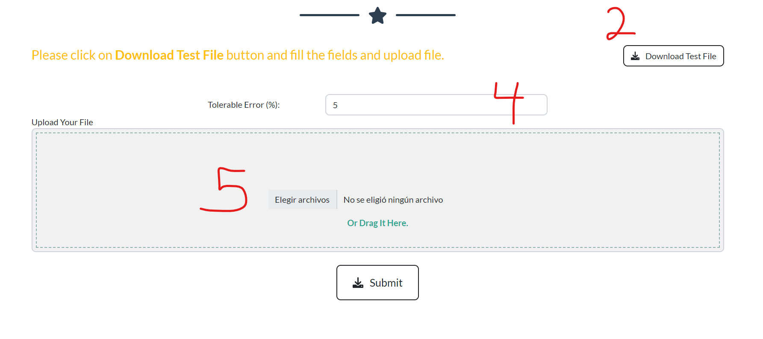
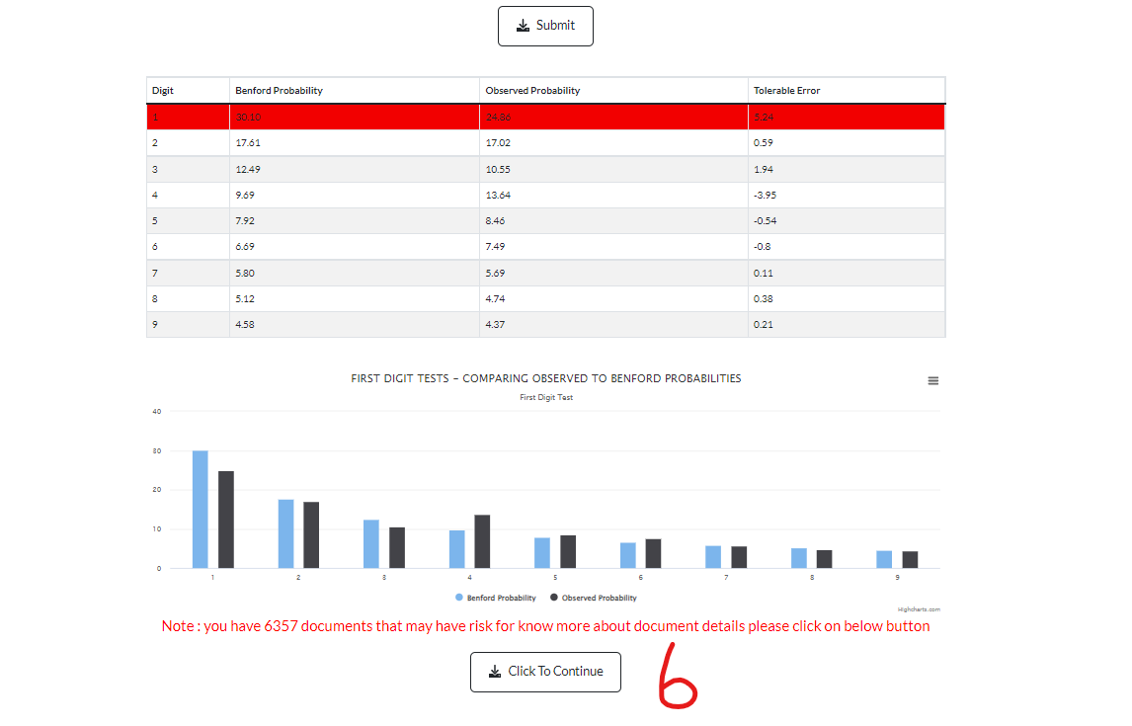

- Go to Ethos Fraud
- Download Test File:
- Fill the data on the Excel file and save it
- Choose Tolerable Error
- Upload file and press submit
- Press Click to Continue to see detail
- Export to excel

